Operating System (KCA-203)
Unit-1

Operating System lies in the category of system software. It basically manages all the resources of the computer. An operating system acts as an interface between the software and different parts of the computer or the computer hardware. The operating system is designed in such a way that it can manage the overall resources and operations of the computer.
Operating System is a fully integrated set of specialized programs that handle all the operations of the computer. It controls and monitors the execution of all other programs that reside in the computer, which also includes application programs and other system software of the computer. Examples of Operating Systems are Windows, Linux, Mac OS, etc.
An Operating System (OS) is a collection of software that manages computer hardware resources and provides common services for computer programs. The operating system is the most important type of system software in a computer system.
What is an Operating System Used for?
The operating system helps in improving the computer software as well as hardware. Without OS, it became very difficult for any application to be user-friendly. The Operating System provides a user with an interface that makes any application attractive and user-friendly. The operating System comes with a large number of device drivers that make OS services reachable to the hardware environment. Each and every application present in the system requires the Operating System. The operating system works as a communication channel between system hardware and system software. The operating system helps an application with the hardware part without knowing about the actual hardware configuration. It is one of the most important parts of the system and hence it is present in every device, whether large or small device.

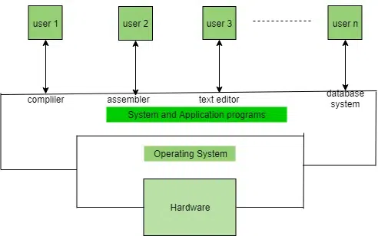

Why are Operating Systems Used?
Operating System is used as a communication channel between the Computer hardware and the user. It works as an intermediate between System Hardware and End-User. Operating System handles the following responsibilities:
- It controls all the computer resources.
- It provides valuable services to user programs.
- It coordinates the execution of user programs.
- It provides resources for user programs.
- It provides an interface (virtual machine) to the user.
- It hides the complexity of software.
- It supports multiple execution modes.
- It monitors the execution of user programs to prevent errors.

Functions of an Operating System

Memory Management
The operating system manages the Primary Memory or Main Memory. Main memory is made up of a large array of bytes or words where each byte or word is assigned a certain address. Main memory is fast storage and it can be accessed directly by the CPU. For a program to be executed, it should be first loaded in the main memory. An operating system manages the allocation and deallocation of memory to various processes and ensures that the other process does not consume the memory allocated to one process. An Operating System performs the following activities for Memory Management:
- It keeps track of primary memory, i.e., which bytes of memory are used by which user program. The memory addresses that have already been allocated and the memory addresses of the memory that has not yet been used.
- In multiprogramming, the OS decides the order in which processes are granted memory access, and for how long.
- It Allocates the memory to a process when the process requests it and deallocates the memory when the process has terminated or is performing an I/O operation.
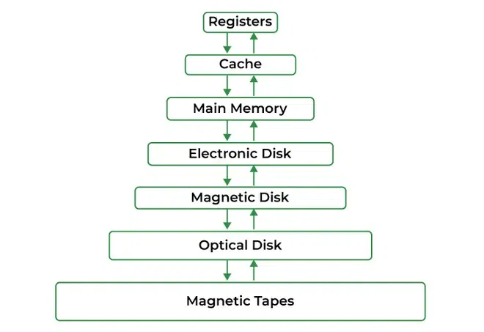

Processor Management
In a multi-programming environment, the OS decides the order in which processes have access to the processor, and how much processing time each process has. This function of OS is called Process Scheduling. An Operating System performs the following activities for Processor Management.
An operating system manages the processor’s work by allocating various jobs to it and ensuring that each process receives enough time from the processor to function properly.
Keeps track of the status of processes. The program which performs this task is known as a traffic controller. Allocates the CPU that is a processor to a process. De-allocates processor when a process is no longer required.

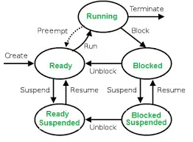

Device Management
An OS manages device communication via its respective drivers. It performs the following activities for device management.
Keeps track of all devices connected to the system. Designates a program responsible for every device known as the Input/Output controller.
Decide which process gets access to a certain device and for how long.
Allocates devices effectively and efficiently. Deallocates devices when they are no longer required.
There are various input and output devices. An OS controls the working of these input-output devices.
It receives the requests from these devices, performs a specific task, and communicates back to the requesting process.

File Management
A file system is organized into directories for efficient or easy navigation and usage. These directories may contain other directories and other files. An Operating System carries out the following file management activities. It keeps track of where information is stored, user access settings, the status of every file, and more. These facilities are collectively known as the file system. An OS keeps track of information regarding the creation, deletion, transfer, copy, and storage of files in an organized way. It also maintains the integrity of the data stored in these files, including the file directory structure, by protecting against unauthorized access.
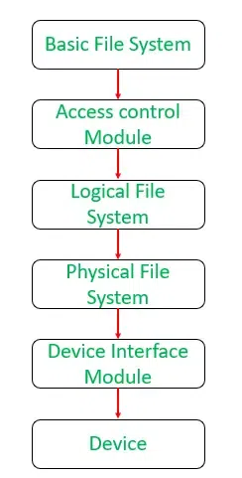

User Interface or Command Interpreter
The user interacts with the computer system through the operating system. Hence OS acts as an interface between the user and the computer hardware. This user interface is offered through a set of commands or a graphical user interface (GUI). Through this interface, the user makes interacts with the applications and the machine hardware.
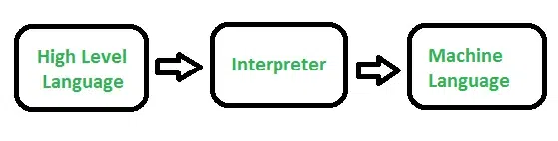

Booting the Computer
The process of starting or restarting the computer is known as booting. If the computer is switched off completely and if turned on then it is called cold booting. Warm booting is a process of using the operating system to restart the computer.
Security
The operating system uses password protection to protect user data and similar other techniques. it also prevents unauthorized access to programs and user data. The operating system provides various techniques which assure the integrity and confidentiality of user data. The following security measures are used to protect user data:
- Protection against unauthorized access through login.
- Protection against intrusion by keeping the firewall active.
- Protecting the system memory against malicious access.
- Displaying messages related to system vulnerabilities.

Control Over System Performance
Operating systems play a pivotal role in controlling and optimizing system performance. They act as intermediaries between hardware and software, ensuring that computing resources are efficiently utilized. One fundamental aspect is resource allocation, where the OS allocates CPU time, memory, and I/O devices to different processes, striving to provide fair and optimal resource utilization. Process scheduling, a critical function, helps decide which processes or threads should run when preventing any single task from monopolizing the CPU and enabling effective multitasking.

Job Accounting
The operating system Keeps track of time and resources used by various tasks and users, this information can be used to track resource usage for a particular user or group of users. In a multitasking OS where multiple programs run simultaneously, the OS determines which applications should run in which order and how time should be allocated to each application.

Error-Detecting Aids
The operating system constantly monitors the system to detect errors and avoid malfunctioning computer systems. From time to time, the operating system checks the system for any external threat or malicious software activity. It also checks the hardware for any type of damage. This process displays several alerts to the user so that the appropriate action can be taken against any damage caused to the system.

Coordination Between Other Software and Users
Operating systems also coordinate and assign interpreters, compilers, assemblers, and other software to the various users of the computer systems. In simpler terms, think of the operating system as the traffic cop of your computer. It directs and manages how different software programs can share your computer’s resources without causing chaos. It ensures that when you want to use a program, it runs smoothly without crashing or causing problems for others. So, it’s like the friendly officer ensuring a smooth flow of traffic on a busy road, making sure everyone gets where they need to go without any accidents or jams.

Performs Basic Computer Tasks
The management of various peripheral devices such as the mouse, keyboard, and printer is carried out by the operating system. Today most operating systems are plug-and-play. These operating systems automatically recognize and configure the devices with no user interference.
Network Management

Network Communication: Think of them as traffic cops for your internet traffic. Operating systems help computers talk to each other and the internet. They manage how data is packaged and sent over the network, making sure it arrives safely and in the right order.

Settings and Monitoring: Think of them as the settings and security guard for your internet connection. They also let you set up your network connections, like Wi-Fi or Ethernet, and keep an eye on how your network is doing. They make sure your computer is using the network efficiently and securely, like adjusting the speed of your internet or protecting your computer from online threats.

Services Provided by an Operating System
The Operating System provides certain services to the users which can be listed in the following manner:

User Interface: Almost all operating systems have a user interface (UI). This interface can take several forms. One is a command-line interface(CLI), which uses text commands and a method for entering them (say, a keyboard for typing in commands in a specific format with specific options). Another is a batch interface, in which commands and directives to control those commands are entered into files, and those files are executed. Most commonly, a graphical user interface (GUI) is used. the interface is a window system with a pointing device to direct I/O, choose from menus, and make selections and a keyboard to enter text.

Program Execution: The Operating System is responsible for the execution of all types of programs whether it be user programs or system programs. The Operating System utilizes various resources available for the efficient running of all types of functionalities.

Handling Input/Output Operations: The Operating System is responsible for handling all sorts of inputs, i.e., from the keyboard, mouse, desktop, etc. The Operating System does all interfacing most appropriately regarding all kinds of Inputs and Outputs.
For example, there is a difference between all types of peripheral devices such as mice or keyboards, the Operating System is responsible for handling data between them.
Manipulation of File System: The Operating System is responsible for making decisions regarding the storage of all types of data or files, i.e., floppy disk/hard disk/pen drive, etc. The Operating System decides how the data should be manipulated and stored.

Resource Allocation: The Operating System ensures the proper use of all the resources available by deciding which resource to be used by whom for how much time. All the decisions are taken by the Operating System.

Accounting: The Operating System tracks an account of all the functionalities taking place in the computer system at a time. All the details such as the types of errors that occurred are recorded by the Operating System.

Information and Resource Protection: The Operating System is responsible for using all the information and resources available on the machine in the most protected way. The Operating System must foil an attempt from any external resource to hamper any sort of data or information.

Communication: The operating system implements communication between one process to another process to exchange information. Such communication may occur between processes that are executing on the same computer or between processes that are executing on different computer systems tied together by a computer network.

System Services: The operating system provides various system services, such as printing, time and date management, and event logging.

Error Detection: The operating system needs to be detecting and correcting errors constantly. Errors may occur in the CPU and memory hardware ( for eg. a memory error or a power failure), in I/O devices (such as a parity error on disk, a connection failure on a network, or a lack of paper in the printer), and in the user program ( an arithmetic overflow, an attempt to access an illegal memory location or a too-great use of CPU time). For each type of error, the operating system should take the appropriate action to ensure correct and consistent computing.
All these services are ensured by the Operating System for the convenience of the users to make the programming task easier. All different kinds of Operating Systems more or less provide the same services.

Characteristics of Operating System
Virtualization: Operating systems can provide Virtualization capabilities, allowing multiple operating systems or instances of an operating system to run on a single physical machine. This can improve resource utilization and provide isolation between different operating systems or applications.
Networking: Operating systems provide networking capabilities, allowing the computer system to connect to other systems and devices over a network. This can include features such as network protocols, network interfaces, and network security.

Scheduling: Operating systems provide scheduling algorithms that determine the order in which tasks are executed on the system. These algorithms prioritize tasks based on their resource requirements and other factors to optimize system performance.

Interprocess Communication: Operating systems provide mechanisms for applications to communicate with each other, allowing them to share data and coordinate their activities.

Performance Monitoring: Operating systems provide tools for monitoring system performance, including CPU usage, memory usage, disk usage, and network activity. This can help identify performance bottlenecks and optimize system performance.

Backup and Recovery: Operating systems provide backup and recovery mechanisms to protect data in the event of system failure or data loss.

Debugging: Operating systems provide debugging tools that allow developers to identify and fix software bugs and other issues in the system.

Types of Operating Systems

An Operating System performs all the basic tasks like managing files, processes, and memory. Thus operating system acts as the manager of all the resources, i.e. resource manager. Thus, the operating system becomes an interface between the user and the machine. It is one of the most required software that is present in the device.
Operating System is a type of software that works as an interface between the system program and the hardware. There are several types of Operating Systems in which many of which are mentioned below. Let’s have a look at them.

Types of Operating Systems

There are several types of Operating Systems which are mentioned below.
- Batch Operating System
- Multi-Programming System
- Multi-Processing System
- Multi-Tasking Operating System
- Time-Sharing Operating System
- Distributed Operating System
- Network Operating System
- Real-Time Operating System

1. Batch Operating System
This type of operating system does not interact with the computer directly. There is an operator which takes similar jobs having the same requirement and groups them into batches. It is the responsibility of the operator to sort jobs with similar needs.
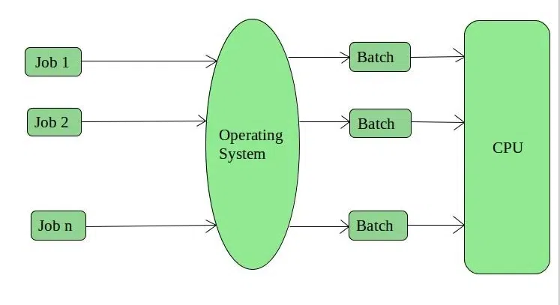
Advantages of Batch Operating System
- Multiple users can share the batch systems.
- The idle time for the batch system is very less.
- It is easy to manage large work repeatedly in batch systems.
Disadvantages of Batch Operating System
- The computer operators should be well known with batch systems.
- Batch systems are hard to debug.
- It is sometimes costly.
- The other jobs will have to wait for an unknown time if any job fails.
- In batch operating system the processing time for jobs is commonly difficult to accurately predict while they are in the queue.
- It is difficult to accurately predict the exact time required for a job to complete while it is in the queue.
Examples of Batch Operating Systems: Payroll Systems, Bank Statements, etc.

2. Multi-Programming Operating System
Multiprogramming Operating Systems can be simply illustrated as more than one program is present in the main memory and any one of them can be kept in execution. This is basically used for better execution of resources.

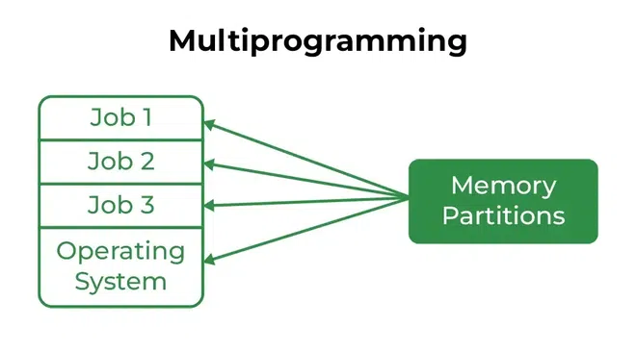
Advantages of Multi-Programming Operating System
- Multi Programming increases the Throughput of the System.
- It helps in reducing the response time.
Disadvantages of Multi-Programming Operating System
- There is not any facility for user interaction of system resources with the system.

3. Multi-Processing Operating System
Multi-Processing Operating System is a type of Operating System in which more than one CPU is used for the execution of resources. It betters the throughput of the System.
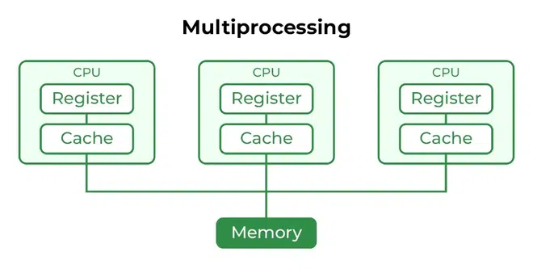
Advantages of Multi-Processing Operating System
- It increases the throughput of the system.
- As it has several processors, so, if one processor fails, we can proceed with another processor.
Disadvantages of Multi-Processing Operating System
- Due to the multiple CPU, it can be more complex and somehow difficult to understand.

4. Multi-Tasking Operating System
Multitasking Operating System is simply a multiprogramming Operating System with having facility of a Round-Robin Scheduling Algorithm. It can run multiple programs simultaneously.
There are two types of Multi-Tasking Systems which are listed below.
- Preemptive Multi-Tasking
- Cooperative Multi-Tasking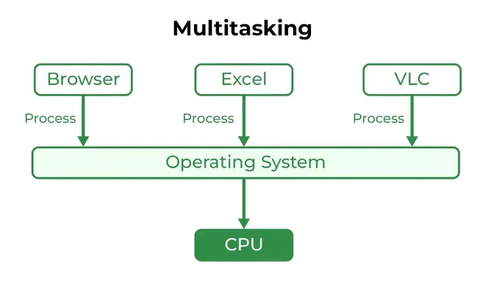
Advantages of Multi-Tasking Operating System
- Multiple Programs can be executed simultaneously in Multi-Tasking Operating System.
- It comes with proper memory management.
Disadvantages of Multi-Tasking Operating System
- The system gets heated in case of heavy programs multiple times.

5. Time-Sharing Operating Systems
Each task is given some time to execute so that all the tasks work smoothly. Each user gets the time of the CPU as they use a single system. These systems are also known as Multitasking Systems. The task can be from a single user or different users also. The time that each task gets to execute is called quantum. After this time interval is over OS switches over to the next task.

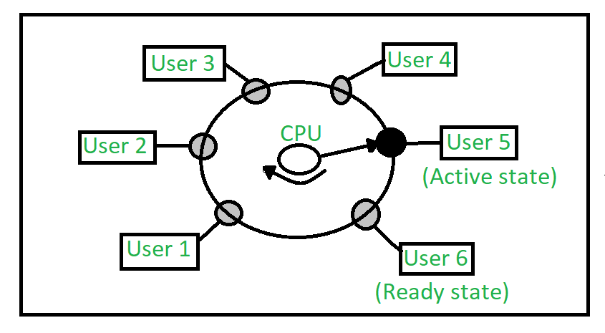
Advantages of Time-Sharing OS
- Each task gets an equal opportunity.
- Fewer chances of duplication of software.
- CPU idle time can be reduced.
- Resource Sharing: Time-sharing systems allow multiple users to share hardware resources such as the CPU, memory, and peripherals, reducing the cost of hardware and increasing efficiency.
- Improved Productivity: Time-sharing allows users to work concurrently, thereby reducing the waiting time for their turn to use the computer. This increased productivity translates to more work getting done in less time.
- Improved User Experience: Time-sharing provides an interactive environment that allows users to communicate with the computer in real time, providing a better user experience than batch processing.
Disadvantages of Time-Sharing OS
- Reliability problem.
- One must have to take care of the security and integrity of user programs and data.
- Data communication problem.
- High Overhead: Time-sharing systems have a higher overhead than other operating systems due to the need for scheduling, context switching, and other overheads that come with supporting multiple users.
- Complexity: Time-sharing systems are complex and require advanced software to manage multiple users simultaneously. This complexity increases the chance of bugs and errors.
- Security Risks: With multiple users sharing resources, the risk of security breaches increases. Time-sharing systems require careful management of user access, authentication, and authorization to ensure the security of data and software.
Examples of Time-Sharing OS with explanation
- IBM VM/CMS: IBM VM/CMS is a time-sharing operating system that was first introduced in 1972. It is still in use today, providing a virtual machine environment that allows multiple users to run their own instances of operating systems and applications.
- TSO (Time Sharing Option): TSO is a time-sharing operating system that was first introduced in the 1960s by IBM for the IBM System/360 mainframe computer. It allowed multiple users to access the same computer simultaneously, running their own applications.
- Windows Terminal Services: Windows Terminal Services is a time-sharing operating system that allows multiple users to access a Windows server remotely. Users can run their own applications and access shared resources, such as printers and network storage, in real-time.

6. Distributed Operating System
These types of operating system is a recent advancement in the world of computer technology and are being widely accepted all over the world and, that too, at a great pace. Various autonomous interconnected computers communicate with each other using a shared communication network. Independent systems possess their own memory unit and CPU. These are referred to as loosely coupled systems or distributed systems. These systems’ processors differ in size and function. The major benefit of working with these types of the operating system is that it is always possible that one user can access the files or software which are not actually present on his system but some other system connected within this network i.e., remote access is enabled within the devices connected in that network.
Advantages of Distributed Operating System
- Failure of one will not affect the other network communication, as all systems are independent of each other.
- Electronic mail increases the data exchange speed.
- Since resources are being shared, computation is highly fast and durable.
- Load on host computer reduces.
- These systems are easily scalable as many systems can be easily added to the network.
- Delay in data processing reduces.
Disadvantages of Distributed Operating System
- Failure of the main network will stop the entire communication.
- To establish distributed systems the language is used not well-defined yet.
- These types of systems are not readily available as they are very expensive. Not only that the underlying software is highly complex and not understood well yet.
Examples of Distributed Operating Systems are LOCUS, etc.
The distributed os must tackle the following issues:
- Networking causes delays in the transfer of data between nodes of a distributed system. Such delays may lead to an inconsistent view of data located in different nodes, and make it difficult to know the chronological order in which events occurred in the system.
- Control functions like scheduling, resource allocation, and deadlock detection have to be performed in several nodes to achieve computation speedup and provide reliable operation when computers or networking components fail.
- Messages exchanged by processes present in different nodes may travel over public networks and pass through computer systems that are not controlled by the distributed operating system. An intruder may exploit this feature to tamper with messages, or create fake messages to fool the authentication procedure and masquerade as a user of the system.

7. Network Operating System
These systems run on a server and provide the capability to manage data, users, groups, security, applications, and other networking functions. These types of operating systems allow shared access to files, printers, security, applications, and other networking functions over a small private network. One more important aspect of Network Operating Systems is that all the users are well aware of the underlying configuration, of all other users within the network, their individual connections, etc. and that’s why these computers are popularly known as tightly coupled systems. 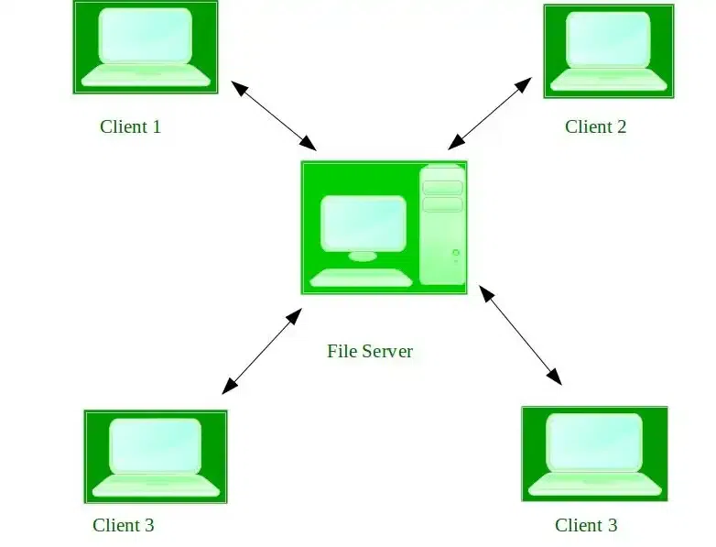

Advantages of Network Operating System
- Highly stable centralized servers.
- Security concerns are handled through servers.
- New technologies and hardware up-gradation are easily integrated into the system.
- Server access is possible remotely from different locations and types of systems.
Disadvantages of Network Operating System
- Servers are costly.
- User has to depend on a central location for most operations.
- Maintenance and updates are required regularly.
Examples of Network Operating Systems are Microsoft Windows Server 2003, Microsoft Windows Server 2008, UNIX, Linux, Mac OS X, Novell NetWare, BSD, etc.

8. Real-Time Operating System
These types of OSs serve real-time systems. The time interval required to process and respond to inputs is very small. This time interval is called response time.
Real-time systems are used when there are time requirements that are very strict like missile systems, air traffic control systems, robots, etc.
Types of Real-Time Operating Systems
- Hard Real-Time Systems:
Hard Real-Time OSs are meant for applications where time constraints are very strict and even the shortest possible delay is not acceptable. These systems are built for saving life like automatic parachutes or airbags which are required to be readily available in case of an accident. Virtual memory is rarely found in these systems.
- Soft Real-Time Systems:
These OSs are for applications where time-constraint is less strict.
Advantages of RTOS
- Maximum Consumption: Maximum utilization of devices and systems, thus more output from all the resources.
- Task Shifting: The time assigned for shifting tasks in these systems is very less. For example, in older systems, it takes about 10 microseconds in shifting from one task to another, and in the latest systems, it takes 3 microseconds.
- Focus on Application: Focus on running applications and less importance on applications that are in the queue.
- Real-time operating system in the embedded system: Since the size of programs is small, RTOS can also be used in embedded systems like in transport and others.
- Error Free: These types of systems are error-free.
- Memory Allocation: Memory allocation is best managed in these types of systems.
Disadvantages of RTOS
- Limited Tasks: Very few tasks run at the same time and their concentration is very less on a few applications to avoid errors.
- Use heavy system resources: Sometimes the system resources are not so good and they are expensive as well.
- Complex Algorithms: The algorithms are very complex and difficult for the designer to write on.
- Device driver and interrupt signals: It needs specific device drivers and interrupts signal to respond earliest to interrupts.
- Thread Priority: It is not good to set thread priority as these systems are very less prone to switching tasks.
Examples of Real-Time Operating Systems are Scientific experiments, medical imaging systems, industrial control systems, weapon systems, robots, air traffic control systems, etc.

Important terms

Context Switching: In most multitasking OSs, multiple running processes on the system may need a change of state in execution. Even if there are multiple processes being executed at any one point in time, only one task is executed in the foreground, while the others are put in the background. So the process that is in the foreground is determined by the priority-based scheduling, and the OS saves the execution state of the previous process before switching to the current one. This is known as context switching.

Buffering: In this technique, input and output data are temporarily stored in Input Buffer and Output Buffer. Once the signal for input or output is sent to or from the CPU respectively, the operating system through the device controller moves the data from the input device to the input buffer and from the output buffer to the output device. In the case of input, if the buffer is full, the operating system sends a signal to the program which processes the data stored in the buffer. When the buffer becomes empty, the program informs the operating system which reloads the buffer and the input operation continues.

Spooling (Simultaneous Peripheral Operation On-Line): This is a device management technique used for processing different tasks on the same input/output device. When there are various users on a network sharing the same resource then it can be a possibility that more than one user might give it a command at the same point in time. So, the operating system temporarily stores the data of every user on the hard disk of the computer to which the resource is attached. The individual user need not wait for the execution process to be completed. Instead, the operating system sends the data from the hard disk to the resource one by one.
Example: printer

Reentrant Kernel: In kernel mode, a reentrant kernel allows processes (or, more precisely, their corresponding kernel threads) to give up the CPU. They have no effect on other processes entering kernel mode. Multiple processor systems may be scheduled together in the case of single-processor systems.
Example:
A disc read is an example of this. When a user program requests a disc read, the scheduler will delegate the CPU to another process (kernel thread) until the disc controller issues an interrupt indicating that the data is accessible and our thread can be resumed. This process can still access I/O, such as user input, which requires kernel functions. The system remains responsive, and the amount of CPU time wasted as a result of IO delays is reduced. The original function (whatever requested data) would be blocked in a non-reentrant kernel until the disc read was completed.
If a computer program or routine can be safely called again before its previous invocation has been completed, it is said to be reentrant (i.e it can be safely executed concurrently). A computer program or routine that is reentrant:
- There cannot be any non-constant data that is static (or global).
- The address must not be returned to static (or global) non-constant data.
- It must only work with the data provided by the caller.
- Locks should not be used to protect singleton resources, a variable that is only referenced once
- It must not change its own code (unless executing in its own unique thread storage).
- Non-reentrant computer programs or routines must not be called.
Non-reentrant functions can still be executed by reentrant kernels if locks are used to ensure that only one process can run the non-reentrant function. Even though the current process is operating in kernel mode, hardware interrupts can suspend it (allowing things like Ctrl+c to cease execution).
Kernel Control Path: A set of instructions that the kernel executes in order to handle a system call. Normally, instructions are executed in order, but some activities force the CPU to interleave control routes. In user mode, the following system call is made: The scheduler chooses a new process to run and switches it on. On behalf of two separate processes, two control pathways are executed.

Difference Between Kernel mode and User mode:
User Mode: When a Program is booted up on an Operating system let’s say Windows, then it launches the program in user mode. When a user-mode program requests to run, a process and virtual address space (address space for that process) are created for it by Windows. User-mode programs are less privileged than user-mode applications and are not allowed to access the system resources directly. For instance, if an application under user mode wants to access system resources, it will have to first go through the Operating system kernel by using syscalls.

Kernel Mode: The kernel is the core program on which all the other operating system components rely, it is used to access the hardware components and schedule which processes should run on a computer system and when, and it also manages the application software and hardware interaction. Hence it is the most privileged program, unlike other programs, it can directly interact with the hardware. When programs running under user mode need hardware access for example webcam, then first it has to go through the kernel by using a syscall, and to carry out these requests the CPU switches from user mode to kernel mode at the time of execution. After finally completing the execution of the process the CPU again switches back to the user mode.

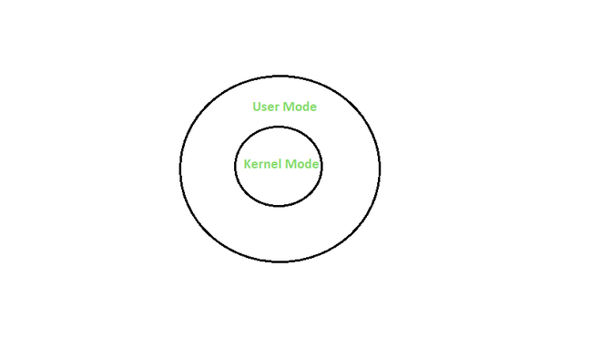

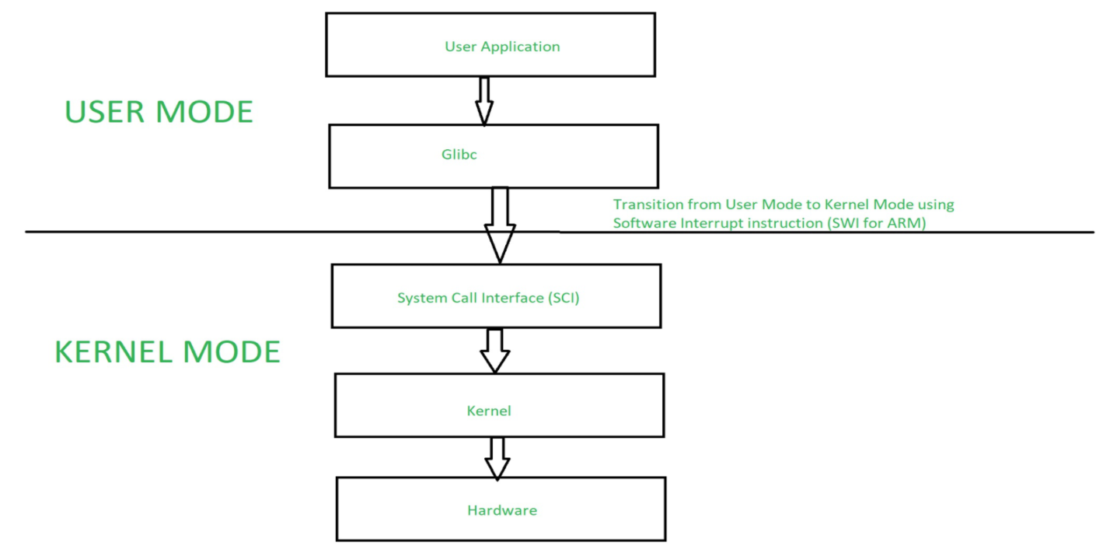

What is a System Call?
A system call is a mechanism used by programs to request services from the operating system (OS). In simpler terms, it is a way for a program to interact with the underlying system, such as accessing hardware resources or performing privileged operations.
A user program can interact with the operating system using a system call. A number of services are requested by the program, and the OS responds by launching a number of systems calls to fulfill the request. A system call can be written in high-level languages like C or Pascal or in assembly language. If a high-level language is used, the operating system may directly invoke system calls, which are predefined functions.
A system call is initiated by the program executing a specific instruction, which triggers a switch to kernel mode, allowing the program to request a service from the OS. The OS then handles the request, performs the necessary operations, and returns the result back to the program.
System calls are essential for the proper functioning of an operating system, as they provide a standardized way for programs to access system resources. Without system calls, each program would need to implement its methods for accessing hardware and system services, leading to inconsistent and error-prone behavior.

Features of System Calls
- Interface: System calls provide a well-defined interface between user programs and the operating system. Programs make requests by calling specific functions, and the operating system responds by executing the requested service and returning a result.
- Protection: System calls are used to access privileged operations that are not available to normal user programs. The operating system uses this privilege to protect the system from malicious or unauthorized access.
- Kernel Mode: When a system call is made, the program is temporarily switched from user mode to kernel mode. In kernel mode, the program has access to all system resources, including hardware, memory, and other processes.
- Context Switching: A system call requires a context switch, which involves saving the state of the current process and switching to the kernel mode to execute the requested service. This can introduce overhead, which can impact system performance.
- Error Handling: System calls can return error codes to indicate problems with the requested service. Programs must check for these errors and handle them appropriately.
- Synchronization: System calls can be used to synchronize access to shared resources, such as files or network connections. The operating system provides synchronization mechanisms, such as locks or semaphores, to ensure that multiple programs can access these resources safely.

How does System Call Work?
Here is a detailed explanation step by step how system calls work:
- Users need special resources: Sometimes programs need to do some special things that can’t be done without the permission of the OS like reading from a file, writing to a file, getting any information from the hardware, or requesting a space in memory.
- The program makes a system call request: There are special predefined instructions to make a request to the operating system. These instructions are nothing but just a “system call”. The program uses these system calls in its code when needed.
- Operating system sees the system call: When the OS sees the system call then it recognizes that the program needs help at this time so it temporarily stops the program execution and gives all the control to a special part of itself called ‘Kernel’. Now ‘Kernel’ solves the need of the program.
- The operating system performs the operations: Now the operating system performs the operation that is requested by the program. Example: reading content from a file etc.
- Operating system give control back to the program : After performing the special operation, OS give control back to the program for further execution of program .

System Call in Windows and Unix

Open(): Accessing a file on a file system is possible with the open() system call. It gives the file resources it needs and a handle the process can use. A file can be opened by multiple processes simultaneously or just one process. Everything is based on the structure and file system.
Read(): Data from a file on the file system is retrieved using it. In general, it accepts three arguments:
- A description of a file.
- A buffer for read data storage.
- How many bytes should be read from the file
Before reading, the file to be read could be identified by its file descriptor and opened using the open() function.
Wait(): In some systems, a process might need to hold off until another process has finished running before continuing. When a parent process creates a child process, the execution of the parent process is halted until the child process is complete. The parent process is stopped using the wait() system call. The parent process regains control once the child process has finished running.
Write(): Data from a user buffer is written using it to a device like a file. A program can produce data in one way by using this system call. generally, there are three arguments:
- A description of a file.
- A reference to the buffer where data is stored.
- The amount of data that will be written from the buffer in bytes.
Fork(): The fork() system call is used by processes to create copies of themselves. It is one of the methods used the most frequently in operating systems to create processes. When a parent process creates a child process, the parent process’s execution is suspended until the child process is finished. The parent process regains control once the child process has finished running.
Exit(): A system call called exit() is used to terminate a program. In environments with multiple threads, this call indicates that the thread execution is finished. After using the exit() system function, the operating system recovers the resources used by the process.

Layered Operating System

Layered Structure is a type of system structure in which the different services of the operating system are split into various layers, where each layer has a specific well-defined task to perform. It was created to improve the pre-existing structures like the Monolithic structure ( UNIX ) and the Simple structure ( MS-DOS ).
Example – The Windows NT operating system uses this layered approach as a part of it.

Design Analysis :
The whole Operating System is separated into several layers ( from 0 to n ) as the diagram shows. Each of the layers must have its own specific function to perform. There are some rules in the implementation of the layers as follows.
- The outermost layer must be the User Interface layer.
- The innermost layer must be the Hardware layer.
- A particular layer can access all the layers present below it but it cannot access the layers present above it. That is layer n-1 can access all the layers from n-2 to 0 but it cannot access the nth layer.
Thus if the user layer wants to interact with the hardware layer, the response will be traveled through all the layers from n-1 to 1. Each layer must be designed and implemented such that it will need only the services provided by the layers below it.
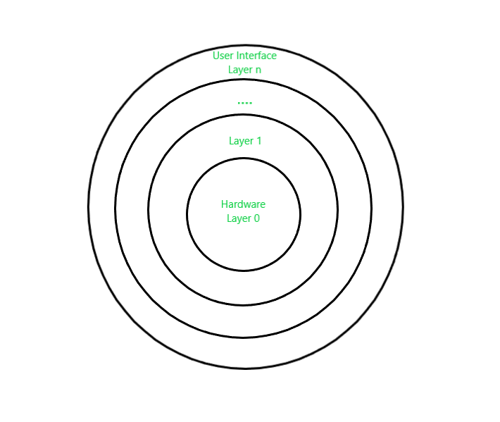
Advantages :
There are several advantages to this design :
- Modularity :
This design promotes modularity as each layer performs only the tasks it is scheduled to perform.
- Easy debugging :
As the layers are discrete so it is very easy to debug. Suppose an error occurs in the CPU scheduling layer, so the developer can only search that particular layer to debug, unlike the Monolithic system in which all the services are present together.
- Easy update :
A modification made in a particular layer will not affect the other layers.
- No direct access to hardware :
The hardware layer is the innermost layer present in the design. So a user can use the services of hardware but cannot directly modify or access it, unlike the Simple system in which the user had direct access to the hardware.
- Abstraction :
Every layer is concerned with its own functions. So the functions and implementations of the other layers are abstract to it.
Disadvantages :
Though this system has several advantages over the Monolithic and Simple design, there are also some disadvantages as follows.
- Complex and careful implementation :
As a layer can access the services of the layers below it, so the arrangement of the layers must be done carefully. For example, the backing storage layer uses the services of the memory management layer. So it must be kept below the memory management layer. Thus with great modularity comes complex implementation.
- Slower in execution :
If a layer wants to interact with another layer, it sends a request that has to travel through all the layers present in between the two interacting layers. Thus it increases response time, unlike the Monolithic system which is faster than this. Thus an increase in the number of layers may lead to a very inefficient design.

Important Components of the Operating System:

Kernel

Shell
- Process management
- Files management
- Command Interpreter
- System calls
- Signals
- Network management
- Security management
- I/O device management
- Secondary storage management
- Main memory management

Kernel in Operating System

Kernel is central component of an operating system that manages operations of computer and hardware. It basically manages operations of memory and CPU time. It is core component of an operating system. Kernel acts as a bridge between applications and data processing performed at hardware level using inter-process communication and system calls.
Kernel loads first into memory when an operating system is loaded and remains into memory until operating system is shut down again. It is responsible for various tasks such as disk management, task management, and memory management.
Kernel has a process table that keeps track of all active processes
• Process table contains a per process region table whose entry points to entries in region table.
Kernel loads an executable file into memory during ‘exec’ system call’.
It decides which process should be allocated to processor to execute and which process should be kept in main memory to execute. It basically acts as an interface between user applications and hardware. The major aim of kernel is to manage communication between software i.e. user-level applications and hardware i.e., CPU and disk memory.
Objectives of Kernel :
- To establish communication between user level application and hardware.
- To decide state of incoming processes.
- To control disk management.
- To control memory management.
- To control task management.
Types of Kernel :
1. Monolithic Kernel –
It is one of types of kernel where all operating system services operate in kernel space. It has dependencies between systems components. It has huge lines of code which is complex.
Example:
Unix, Linux, Open VMS, XTS-400 etc.
Advantage:
1. Efficiency: Monolithic kernels are generally faster than other types of kernels because they don’t have to switch between user and kernel modes for every system call, which can cause overhead.
2. Tight integration: Since all the operating system services are running in kernel space, they can communicate more efficiently with each other, making it easier to implement complex functionalities and optimizations.
3. Simplicity: Monolithic kernels are simpler to design, implement, and debug than other types of kernels because they have a unified structure that makes it easier to manage the code.
4. Lower latency: Monolithic kernels have lower latency than other types of kernels because system calls and interrupts can be handled directly by the kernel.
Disadvantage:
1. Stability issues: Monolithic kernels can be less stable than other types of kernels because any bug or security vulnerability in a kernel service can affect the entire system.
2. Security vulnerabilities: Since all the operating system services are running in kernel space, any security vulnerability in one of the services can compromise the entire system.
3. Maintenance difficulties: Monolithic kernels can be more difficult to maintain than other types of kernels because any change in one of the services can affect the entire system.
4. Limited modularity: Monolithic kernels are less modular than other types of kernels because all the operating system services are tightly integrated into the kernel space. This makes it harder to add or remove functionality without affecting the entire system.
2. Micro Kernel –
It is kernel types which has minimalist approach. It has virtual memory and thread scheduling. It is more stable with less services in kernel space. It puts rest in user space.
It is use in small os.
Example :
Mach, L4, AmigaOS, Minix, K42 etc.

Advantages:
1. Reliability: Microkernel architecture is designed to be more reliable than monolithic kernels. Since most of the operating system services run outside the kernel space, any bug or security vulnerability in a service won’t affect the entire system.
2. Flexibility: Microkernel architecture is more flexible than monolithic kernels because it allows different operating system services to be added or removed without affecting the entire system.
3. Modularity: Microkernel architecture is more modular than monolithic kernels because each operating system service runs independently of the others. This makes it easier to maintain and debug the system.
4. Portability: Microkernel architecture is more portable than monolithic kernels because most of the operating system services run outside the kernel space. This makes it easier to port the operating system to different hardware architectures.
Disadvantages:
1. Performance: Microkernel architecture can be slower than monolithic kernels because it requires more context switches between user space and kernel space.
2. Complexity: Microkernel architecture can be more complex than monolithic kernels because it requires more communication and synchronization mechanisms between the different operating system services.
3. Development difficulty: Developing operating systems based on microkernel architecture can be more difficult than developing monolithic kernels because it requires more attention to detail in designing the communication and synchronization mechanisms between the different services.
4. Higher resource usage: Microkernel architecture can use more system resources, such as memory and CPU, than monolithic kernels because it requires more communication and synchronization mechanisms between the different operating system services.
3. Hybrid Kernel –
It is the combination of both monolithic kernel and microkernel. It has speed and design of monolithic kernel and modularity and stability of microkernel.
Example :
Windows NT, Netware, BeOS etc.
Advantages:
1. Performance: Hybrid kernels can offer better performance than microkernels because they reduce the number of context switches required between user space and kernel space.
2. Reliability: Hybrid kernels can offer better reliability than monolithic kernels because they isolate drivers and other kernel components in separate protection domains.
3. Flexibility: Hybrid kernels can offer better flexibility than monolithic kernels because they allow different operating system services to be added or removed without affecting the entire system.
4. Compatibility: Hybrid kernels can be more compatible than microkernels because they can support a wider range of device drivers.
Disadvantages:
1. Complexity: Hybrid kernels can be more complex than monolithic kernels because they include both monolithic and microkernel components, which can make the design and implementation more difficult.
2. Security: Hybrid kernels can be less secure than microkernels because they have a larger attack surface due to the inclusion of monolithic components.
3. Maintenance: Hybrid kernels can be more difficult to maintain than microkernels because they have a more complex design and implementation.
4. Resource usage: Hybrid kernels can use more system resources than microkernels because they include both monolithic and microkernel components.
4. Exo Kernel –
It is the type of kernel which follows end-to-end principle. It has fewest hardware abstractions as possible. It allocates physical resources to applications.
Example :
Nemesis, ExOS etc.
Advantages:
1. Flexibility: Exokernels offer the highest level of flexibility, allowing developers to customize and optimize the operating system for their specific application needs.
2. Performance: Exokernels are designed to provide better performance than traditional kernels because they eliminate unnecessary abstractions and allow applications to directly access hardware resources.
3. Security: Exokernels provide better security than traditional kernels because they allow for fine-grained control over the allocation of system resources, such as memory and CPU time.
4. Modularity: Exokernels are highly modular, allowing for the easy addition or removal of operating system services.
Disadvantages:
1. Complexity: Exokernels can be more complex to develop than traditional kernels because they require greater attention to detail and careful consideration of system resource allocation.
2. Development Difficulty: Developing applications for exokernels can be more difficult than for traditional kernels because applications must be written to directly access hardware resources.
3. Limited Support: Exokernels are still an emerging technology and may not have the same level of support and resources as traditional kernels.
4. Debugging Difficulty: Debugging applications and operating system services on exokernels can be more difficult than on traditional kernels because of the direct access to hardware resources.
5. Nano Kernel –
It is the type of kernel that offers hardware abstraction but without system services. Micro Kernel also does not have system services therefore the Micro Kernel and Nano Kernel have become analogous.
Example :
EROS etc.
Advantages:
1. Small size: Nanokernels are designed to be extremely small, providing only the most essential functions needed to run the system. This can make them more efficient and faster than other kernel types.
2. High modularity: Nanokernels are highly modular, allowing for the easy addition or removal of operating system services, making them more flexible and customizable than traditional monolithic kernels.
3. Security: Nanokernels provide better security than traditional kernels because they have a smaller attack surface and a reduced risk of errors or bugs in the code.
4. Portability: Nanokernels are designed to be highly portable, allowing them to run on a wide range of hardware architectures.
Disadvantages:
1. Limited functionality: Nanokernels provide only the most essential functions, making them unsuitable for more complex applications that require a broader range of services.
2. Complexity: Because nanokernels provide only essential functionality, they can be more complex to develop and maintain than other kernel types.
3. Performance: While nanokernels are designed for efficiency, their minimalist approach may not be able to provide the same level of performance as other kernel types in certain situations.
4. Compatibility: Because of their minimalist design, nanokernels may not be compatible with all hardware and software configurations, limiting their practical use in certain contexts.

